Before you travel don’t forget!!!
Updated as of 10 December 2025
Mauritius:
- Passport: must be valid for 6 months on arrival.
- All-in-one Mauritius form: must be completed before checking in for one’s flight: https://safemauritius.govmu.org
- Tourism Levy: All hotel guests are required to pay a tourist fee of Euro 3 per guest, aged 12 and older, per night as per the Mauritius Revenue Authority. This amount must be paid directly to the hotel upon check out.
- Airlines and authorities sometimes ask for travel documents: We recommend that clients carry copies (electronic or printed) of itinerary, vouchers and tickets and any other completed online forms.
Seychelles:
- Passport: Must be valid for the period of the intended stay until arrival back in the holder’s country of origin or residence.
- Immigration form: All travellers are required to complete immigration procedures when travelling to and from Seychelles. Please click https://seychelles.govtas.com/ for access to the immigration forms. There is a cost to passengers:
  - Adults:
    - Standard processing times (24hrs before departure) – Euros 10
    - Premium processing (6hrs before departure) – Euros 30
    - Expedited processing (60 minutes before departure) – Euros 70
  - Children (12 yrs and under)
    - Standard processing times (24hrs) – Euros 10
    - Premium processing (6hrs) – Euros 30
    - Expedited processing (60 minutes) – Euros 30
- Tourism Levy: All hotel guests are required to pay a tourism environmental sustainability levy of SCR 100 (Approx R150) per guest per night at the time of check in. children under the age of 13 and Seychellois citizens are exempt.
- Airlines and authorities sometimes ask for travel documents: We recommend that clients carry copies (electronic or printed) of itinerary, vouchers and tickets and any other completed online forms.
Maldives:
- Passport: Must be valid for the period of the intended stay from check-in date.
- Travel declaration online form:
  - All travellers are required to complete the Maldives Traveller Declaration online form. This form must be completed 96 hours (4 days) before arrival in the Maldives.
  - There is no cost
  - Please click https://imuga.immigration.gov.mv/traveller to complete the form
- Alcohol Ban: There is a complete ban on importing alcohol in the Maldives. Duty-free purchases are no exception: they are confiscated upon arrival.
- Tourism Taxes and or Levy: These are included in the packages and are therefore pre-paid.
- Airlines and authorities sometimes ask for travel documents: We recommend that clients carry copies (electronic or printed) of itinerary, vouchers and tickets and any other completed online forms.
Zanzibar:
- Passport: must be valid for 6 months after the end of the client’s stay.
- Mandatory Travel Insurance:
  - All International visitors are required to purchase the mandatory inbound insurance
  - For SADC country including South Africa the insurance is 50% discount which is 22USD
  - All International visitors are required to purchase the mandatory inbound insurance at a cost of $44 per person.
  - This can only be obtained through the Zanzibar Insurance corporation via the website https://visitzanzibar.go.tz
  - It is recommended that clients still purchase their own fully comprehensive travel Insurance
  - There are various plans available:
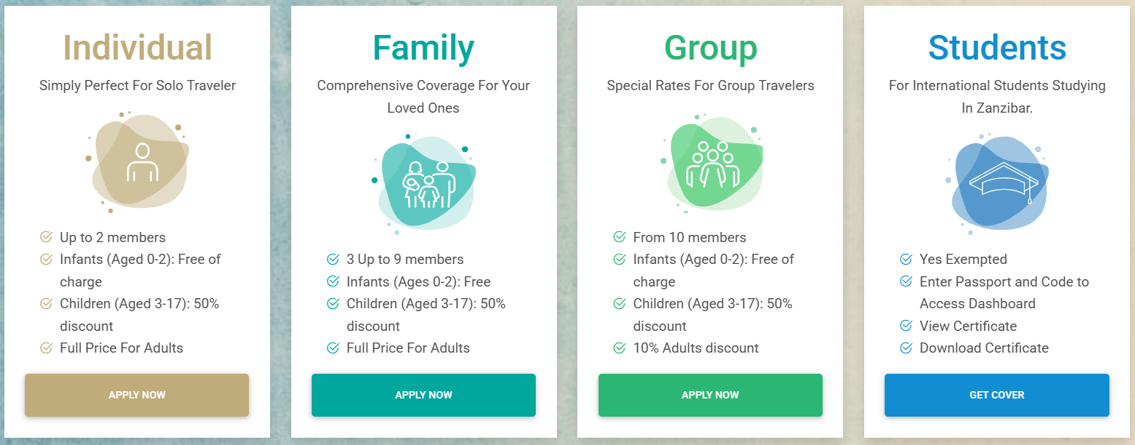
- Airlines will request proof of the mandatory insurance, accommodation and return air ticket at check in.
- Completed Entry Form: This document must be completed and is available at the immigration checkpoint. Some airlines may provide it on the plane.
- Government Infrastructure Tax: All hotel guests are required to pay an infrastructure tax of $5 per guest per night. This amount must be paid directly to the hotel upon check out.
- Airlines and authorities sometimes ask for travel documents: We recommend that clients carry copies (electronic or printed) of itinerary, vouchers and tickets and any other completed online forms.

Thailand:
- Passport: Must be valid for at least six months from the client’s arrival date.
- The Thailand Digital Arrival Card:
  - All travellers are required to complete The Thailand Digital Arrival Card.
  - This document must be completed 3 days before arrival in Thailand.
  - There is no cost.
  - Please click https://tdac.immigration.go.th to complete the online document.
- Hotel levy for incidentals:
  - It is common practice for hotel to request deposit of between 1000 (R500) – 3000 (R1,500) Thai Baht on arrival per day.
- Airlines and authorities sometimes ask for travel documents: We recommend that clients carry copies (electronic or printed) of itinerary, vouchers and tickets and any other completed online forms.
Bali:
- Passport: Must be valid for the period of the intended stay until arrival back in the holder’s country of origin or residence.
- Forms:
  - On September 1, Indonesia introduced the ‘All Indonesia’ online declaration card, which all international travellers must fill out prior to arrival.
  - Arrivals at Soekarno-Hatta International Airport in Jakarta, Juanda International Airport in Surabaya and I Gusti Ngurah Rai Airport in Bali can complete the application at https://allindonesia.imigrasi.go.id/
  - The new system integrates immigration, customs and health forms into one application. This means international passengers no longer need to fill out separate electronic customs and health declarations.
- Mandatory Tourism Levy
  - Bali has imposed a Tourism Levy which is payable online prior to arrival. The cost is from USD10 per person or IDR 150,000 per person. To pay this levy, please go to https://lovebali.baliprov.go.id to complete passport information and process the online payment to receive the levy voucher.
- Visa:
  - South African passport holders can enter Bali without a visa for a 30-day stay, but they must obtain a Visa on Arrival (VoA). The VoA can be obtained online before travel via e-VoA https://evisa.imigrasi.go.id/ or in person upon arrival at the airport. There is a cost of 35 USD
- Travellers will be asked for printed proof of accommodation, tickets, visas etc., please ensure you have these on hand

And lastly, always travel with fully comprehensive travel insurance

